Crystal Catalogue for Offer

Welcome to our exclusive Crystal Catalogue, where beauty meets energy. Each crystal in this collection is carefully selected for its unique properties and stunning appearance, making them perfect for personal use, gifting, or Offer. Crystals have long been revered for their metaphysical properties, and now you can experience their power firsthand.

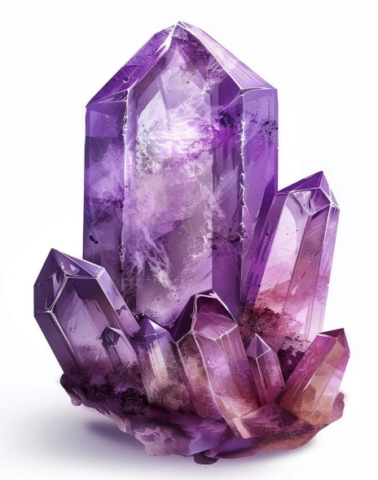1.Amethyst

Properties: Known as the stone of peace and tranquility, amethyst is believed to calm the mind, enhance intuition, and promote spiritual growth.

Uses: Ideal for meditation, stress relief, or creating a peaceful environment.

Offer: 10% off when buying in bundles of three.

Sizes Available:

• Small Tumbled Stones

• Raw Crystals

• Polished Geodes

2.Rose Quartz

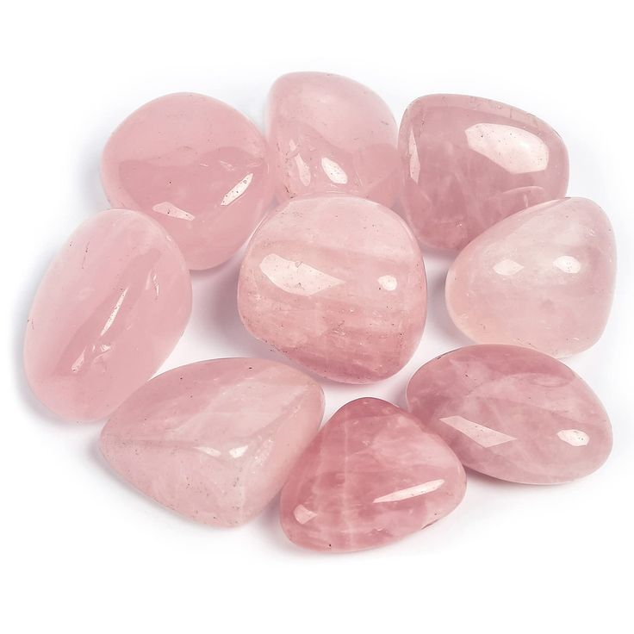Properties: The stone of love, Rose Quartz is believed to foster self-love, compassion, and emotional healing.

Uses: Perfect for promoting love and harmony in relationships, or for soothing emotional stress.

Offer: Free velvet pouch with every Rose Quartz purchase.

Sizes Available:

• Tumbled Stones

• Heart-Shaped Crystals

• Large Sculptures

3.Clear Quartz

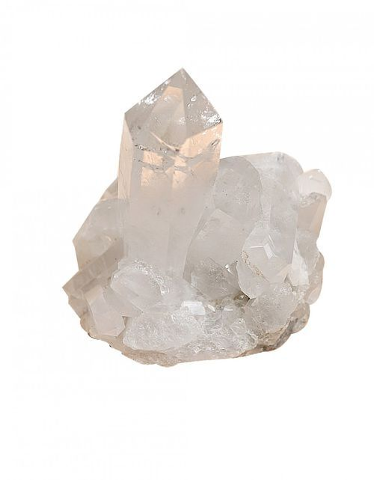Properties: Known as the “Master Healer,” Clear Quartz amplifies energy and thought, making it perfect for healing and personal growth.

Uses: Popular for energy cleansing, amplifying intentions, or as a general-purpose healing stone.

Offer: Buy one, get one 50% off!

Sizes Available:

• Raw Quartz Clusters

• Polished Points

• Spheres

4.Citrine

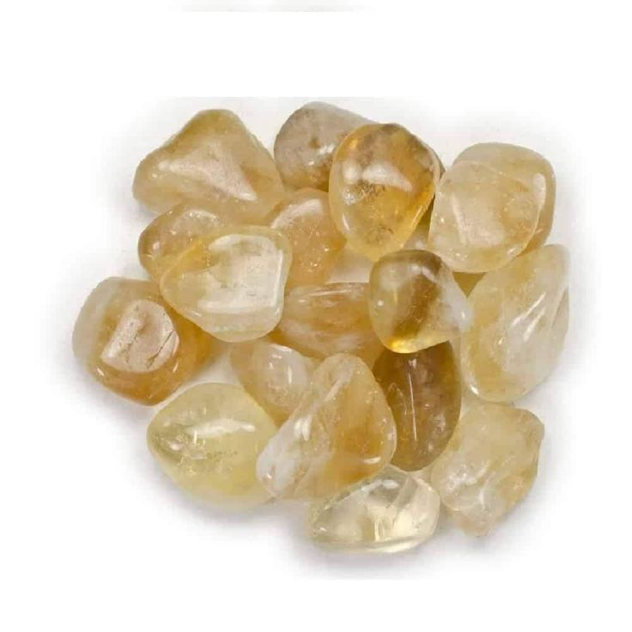Properties: The stone of abundance and positivity, Citrine is said to promote financial prosperity, creativity, and confidence.

Uses: Ideal for manifesting success, improving mood, and clearing negative energy.

Offer: 15% off for the first 100 orders!

Sizes Available:

• Raw Specimens

• Polished Stones

• Tumbled Crystals

5.Selenite

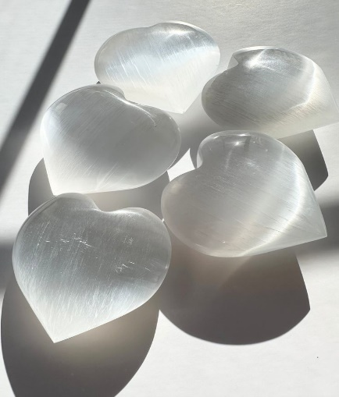Properties: Known for its powerful cleansing properties, Selenite clears negative energy and promotes mental clarity and peace.

Uses: Perfect for use in meditation, energy healing, and cleansing other crystals.

Offer: Complimentary Selenite Wand with every order over $75.

Sizes Available:

• Selenite Wands

• Charging Plates

• Selenite Lamps

6.Tiger’s Eye

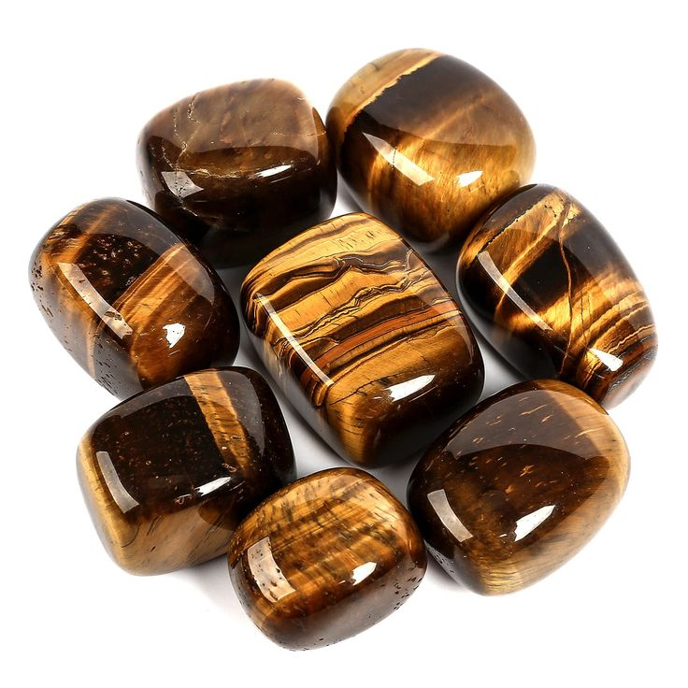Properties: A grounding stone that promotes courage, strength, and confidence. Tiger’s Eye is believed to enhance willpower and mental clarity.

Uses: Excellent for balancing energy, protecting against negative influences, and boosting self-esteem.

Offer: Exclusive discounts for bulk orders.

Sizes Available:

• Tumbled Stones

• Beads

• Polished Spheres

7.Lapis Lazuli

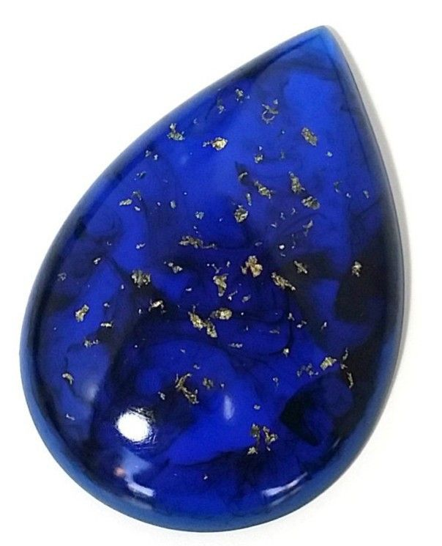Properties: Known for its deep blue color, Lapis Lazuli is linked to wisdom, communication, and spiritual enlightenment.

Uses: Ideal for opening the third eye chakra and stimulating intellectual and spiritual growth.

Offer: Free gift with the purchase of any Lapis Lazuli item.

Sizes Available:

• Raw Stones

• Polished Pendants

• Tumbled Stones

8.Black Tourmaline

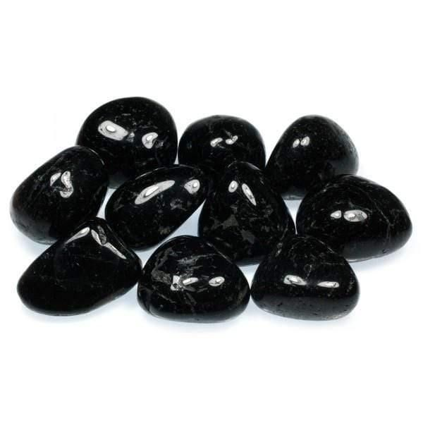Properties: A powerful protective stone, Black Tourmaline absorbs negative energy and offers grounding and stability.

Uses: Ideal for shielding against EMF radiation, negative influences, and for enhancing emotional well-being.

Offer: 20% off on select Black Tourmaline products.

Sizes Available:

• Raw Crystals

• Tumbled Stones

• Protective Shields

9.Fluorite

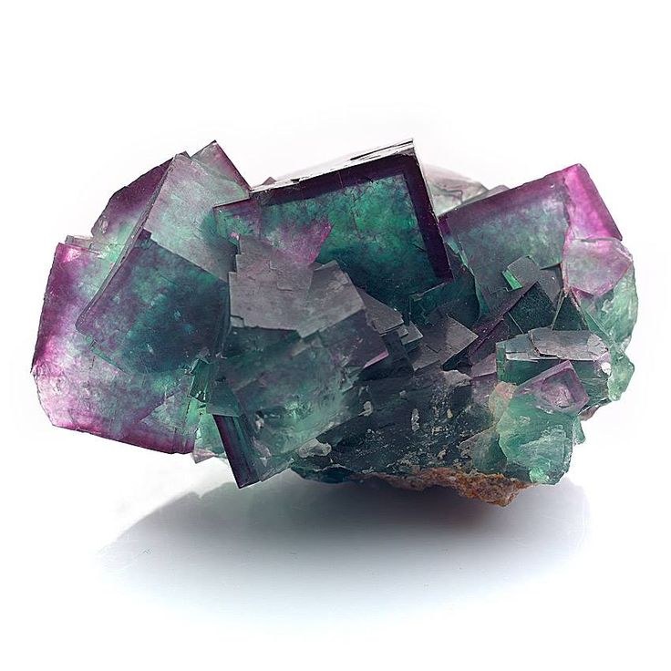Properties: Known for its vibrant colors, Fluorite is a crystal of clarity, healing, and focus. It’s said to clear the mind and help in decision-making.

Uses: Excellent for boosting concentration, clearing negativity, and enhancing personal growth.

Offer: Free shipping on all Fluorite orders.

Sizes Available:

• Polished Pieces

• Fluorite Blocks

• Tumbled Stones

**Gift Sets & Bundles**

**1. Healing Energy Set**

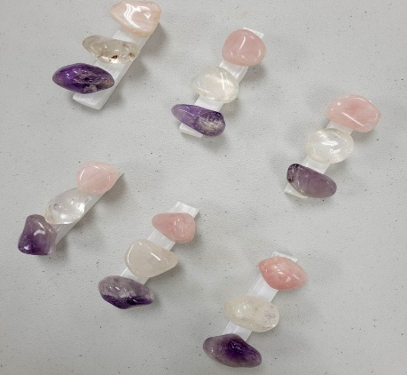Includes:

• Amethyst

• Rose Quartz

• Clear Quartz

• Selenite Wand

Offer: Save 25% when purchasing as a set.

**2. Protection & Grounding Bundle**

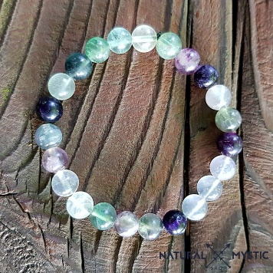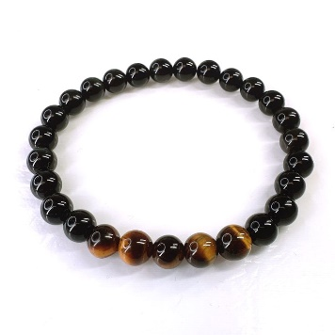Includes:

• Black Tourmaline

• Tiger’s Eye

• Fluorite

Offer: Free pouch included with bundle purchase.

**3. Prosperity and Abundance Pack**

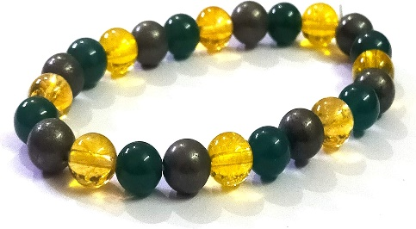Includes:

• Citrine

• Green Aventurine

• Pyrite

Offer: 15% off when purchasing all three.